Differentiate and Compare the HR Policies of One MNC (L&T) and One Local company(mega Engineering and Infrastructure)
 | Larsen & Toubro (L&T) | Mega Engineering and Infrastructure
logo | 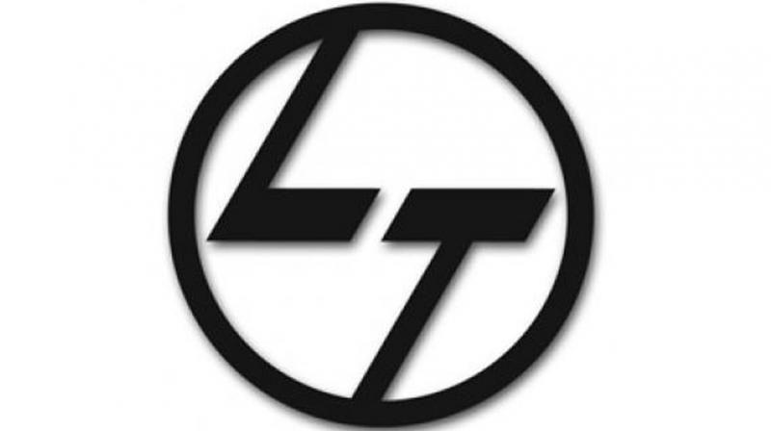 | 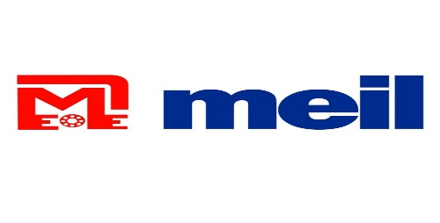
Owner/CEO | Subrahmanyan (S. N. Subrahmanyan) | P.P Reddy(Pamireddy Pitch Reddy)
Introduction | - Founding and Background:  - Founded in 1938 in Bombay (by Danish engineers Henning Holck-Larsen and Søren Kristian Toubro.  - Industry and Operations:  - L&T various sectors:  - Construction and Infrastructure: L&T is a major player in EPC (Engineering, Procurement, and Construction) projects.  - Information Technology: L&T has a strong IT services arm.  - Financial Services: The company is involved in financial operations.  - Military: L&T contributes to defense-related projects.  - Global Reach:  - L&T operates in over 50 countries worldwide.  - It has subsidiaries, joint ventures, and associate companies across different geographies.  - Size and Financials (as of 2024):  - Revenue: ₹225,271 crore (approximately US$27 billion).  - Operating Income: ₹20,424 crore (approximately US$2.4 billion).  - Total Assets: ₹339,627 crore (approximately US$41 billion).  - Total Equity: ₹102,550 crore (approximately US$12 billion).  - Number of Employees: 407,438 (including 348,094 workmen). | - Founding and Background:  - Establishment: MEIL was founded in 1989 as a small fabrication unit.  - Industry Presence:  - Multi-Sector Conglomerate: MEIL operates across diverse industries, including:  - Hydrocarbons: Handling complex hydrocarbon projects globally.  - Electric Buses: Contributing to sustainable mobility solutions.  - Defence: Engaged in defense-related projects.  - Telecom: Involved in the telecom industry.  - Power: Undertaking power plant projects.  - Size and Financials (as of 2024):  - Revenue: Approximately $5 billion (₹225,271 crore).  - Operating Income: Approximately $2.4 billion (₹20,424 crore).  - Total Assets: Approximately $41 billion (₹339,627 crore).  - Total Equity: Approximately $12 billion (₹102,550 crore).  - Employees: Over 400,000, including 348,094 workmen.
Recruitment and Selection | - L&T follows a robust recruitment process to identify and onboard skilled individuals.  - They emphasize equal opportunity, diversity, and merit-based selection. | - MEIL follows a rigorous recruitment process to identify and hire talented individuals who align with the company’s values and goals.  - They emphasize diversity and equal opportunity,ensuring a fair and transparent selection process.
Training and Development | - L&T invests in employee development through training programs, workshops, and skill enhancement initiatives.  - Continuous learning is encouraged to foster career growth. | - MEIL invests in employee development through regular training programs, workshops, and skill-building initiatives.  - They encourage continuous learning and provide opportunities for career growth.
Performance Management: | - Regular performance appraisals are conducted to evaluate employee contributions.  - Metrics align with organizational goals, and constructive feedback is provided. | - MEIL evaluates employee performance through regular appraisals.  - Performance metrics are aligned with organizational objectives, and feedback is constructive.
Employee Benefits | - L&T offers competitive compensation, health insurance, and other benefits.  - Employee well-being and work-life balance are prioritized. | - MEIL offers competitive compensation packages, health insurance, and other benefits.  - They prioritize employee well-being and work-life balance.
Work Culture  And Values | - L&T promotes a collaborative, inclusive work environment.  - Their core values include transparency, accountability, and respect. | - MEIL promotes a collaborative, inclusive, and respectful work environment.  - They celebrate achievements, encourage innovation, and recognize outstanding contributions.

Conclusion:The key Differences and Similarities In The HR Policies Of Both Companies.

Name:shravan sapate
Roll N0: 27
branch: CSBS

